In Remote health monitoring system with analytics dashboard, I used node red app. by creating node red layout as follows:

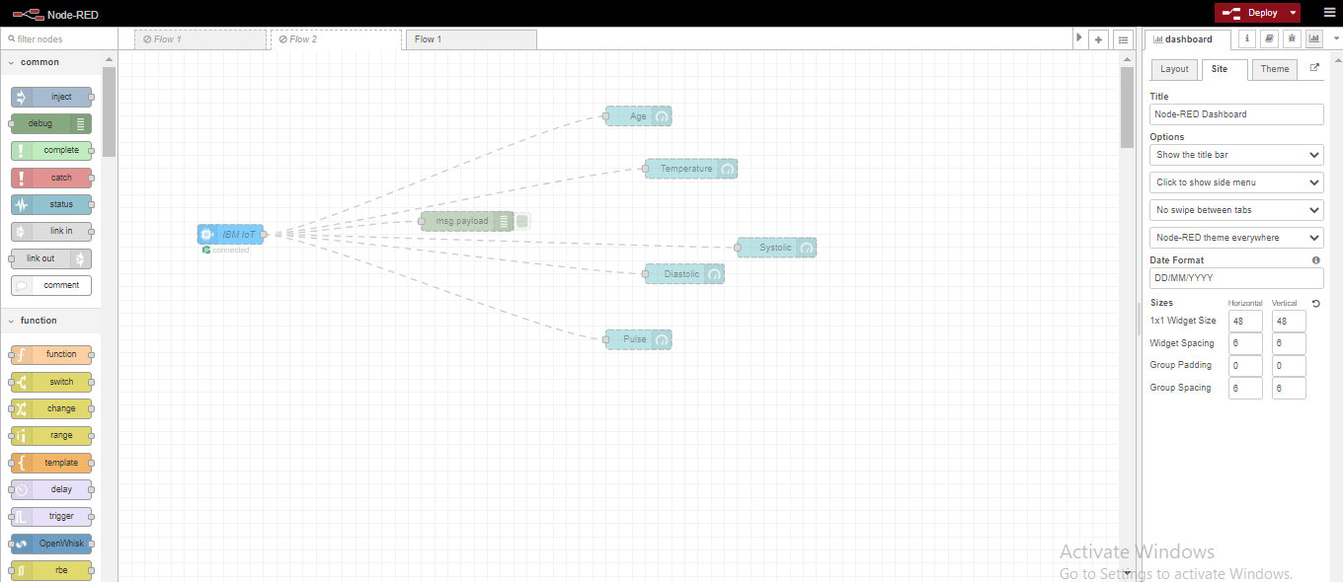

The above is initial node red dashboard. But the final node red which as many functions like timestamp, Pre-token, http request, pre-prediction, msg payload, status and so on and the layout is as follows:

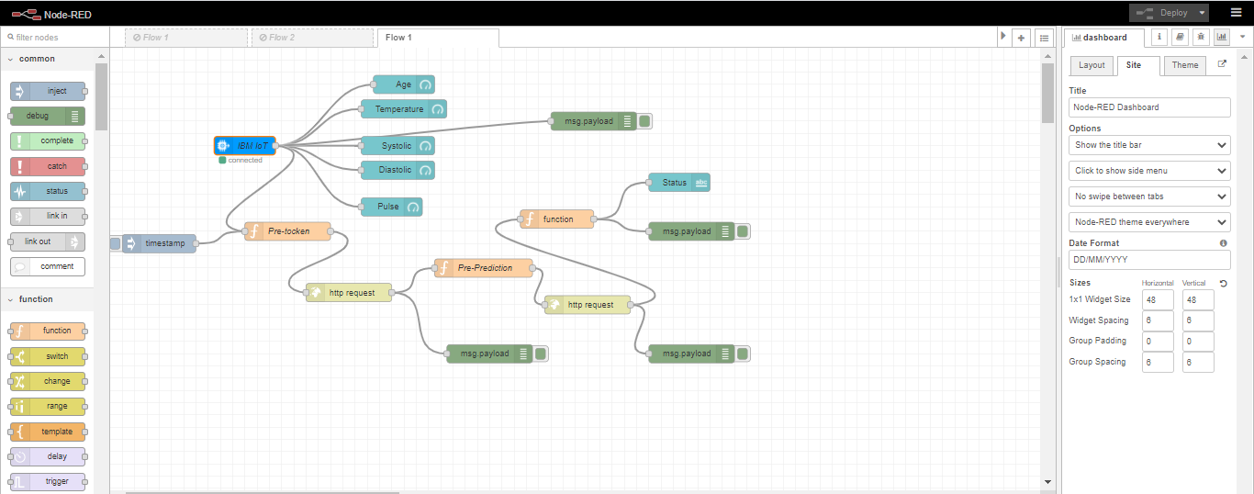

Here IBM watson IOT platform is used to create different events as follows:

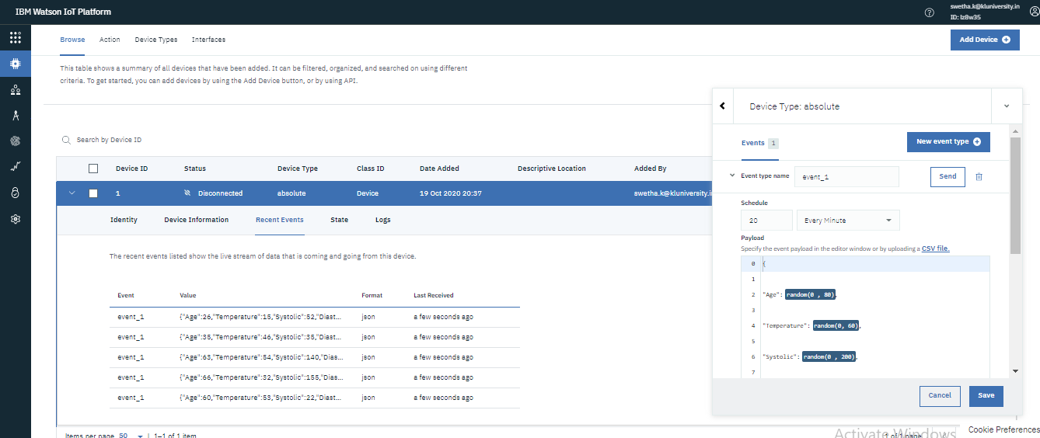

Here we deployed decision tree classifier by using R as follows:

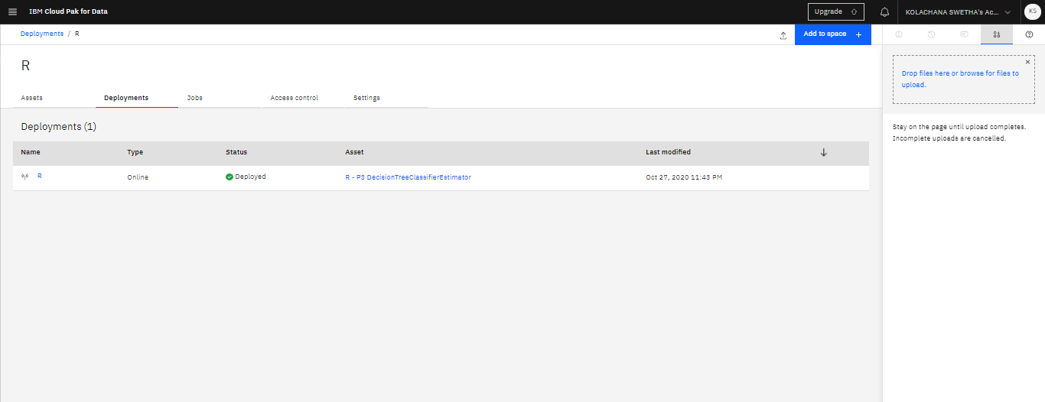

we have created API key successfully as below:

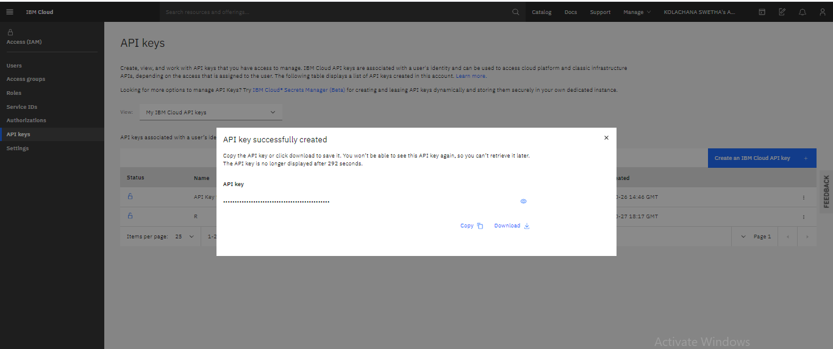

And finally the output includes temperature, Diastolic, systolic, age, pulse as shown below:

